**Importance of yield() method in Java?**

The **yield()** method of thread class causes the currently executing thread object to temporarily pause and allow other threads to execute.

## Syntax

1. public static void yield()

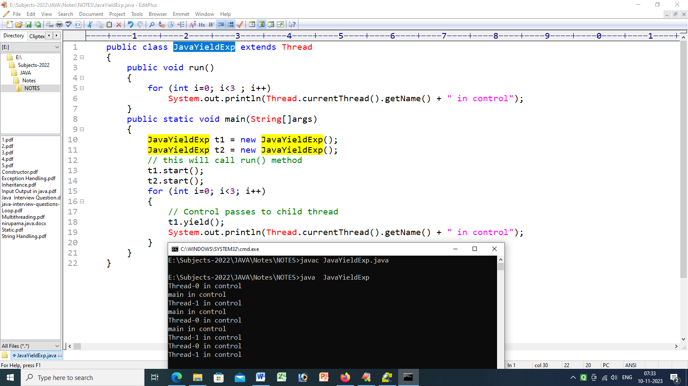

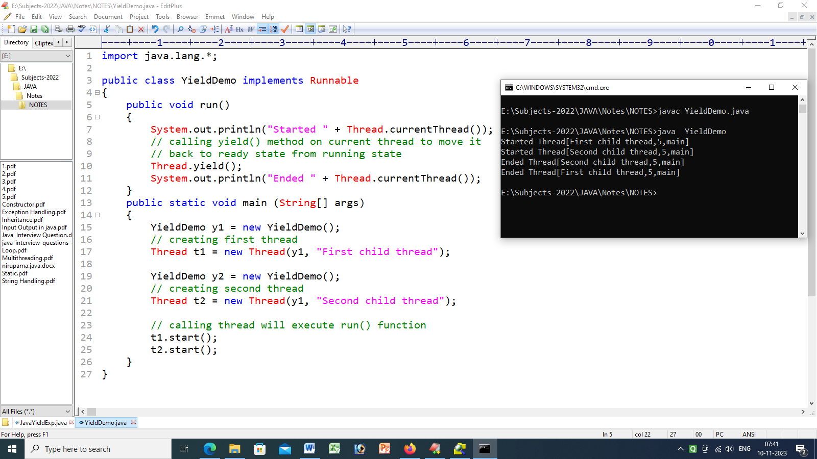

# wait and notify() Methods in Java

public final void wait() throws [InterruptedException](https://docs.oracle.com/en/java/javase/17/docs/api/java.base/java/lang/InterruptedException.html)

Causes the current thread to wait until it is awakened, typically by being *notified* or *interrupted*.

public final void notify()

Wakes up a single thread that is waiting on this object's monitor. If any threads are waiting on this object, one of them is chosen to be awakened. The choice is arbitrary and occurs at the discretion of the implementation. A thread waits on an object's monitor by calling one of the wait methods.

public final void notifyAll()

Wakes up all threads that are waiting on this object's monitor. A thread waits on an object's monitor by calling one of the wait methods.

